EXPT NO:6 | IMPLEMENTATION OF MULTIVARIATE DISPLAYS
Roll No. 23BAD079 | IMPLEMENTATION OF MULTIVARIATE DISPLAYS
DATE: 24.01.2026 | IMPLEMENTATION OF MULTIVARIATE DISPLAYS

PRE-LAB QUESTIONS
- Why are multivariate displays important in AI analytics?

Answer: They show relationships among multiple variables at once, helping detect patterns, correlations, and anomalies in AI data.

- How do parallel coordinates differ from scatter plots?

Answer: Scatter plots show relationships between two variables, while parallel coordinates visualize many variables simultaneously.

- What challenges exist in interpreting multivariate plots?

Answer: Visual clutter, overlapping data, and higher cognitive load make them harder to interpret.

- Where are trellis displays commonly used?

Answer: In comparing patterns across categories, time periods, or model outputs in analytics and AI dashboards.

- How does multivariate visualization aid model evaluation?

Answer: It helps assess feature interactions, model behavior, and performance across multiple metrics at once.

OBJECTIVE : To implement advanced multivariate displays for complex data analysis.

SCENARIO A retail analytics firm studies sales, profit, customer segment, and region to optimize business strategy.

IN-LAB TASKS (Using R Language) • Create parallel coordinate plots • Generate bubble charts • Implement trellis displays by region

CODE:
print("Roll number:23BAD079")

library(ggplot2)
library(GGally)
library(dplyr)

set.seed(123)

retail_data <- data.frame(
Sales = runif(50, 1000, 10000),
Profit = runif(50, -2000, 4000),
Customer_Segment = sample(c("Consumer", "Corporate", "Home Office"), 50, replace = TRUE),
Region = sample(c("North", "South", "East", "West"), 50, replace = TRUE)
)
head(retail_data)

ggparcoord(
data = retail_data,
columns = c(1, 2),
groupColumn = "Customer_Segment",
scale = "uniminmax"
) +
theme_minimal() +
labs(title = "Parallel Coordinate Plot of Sales and Profit")
ggplot(retail_data, aes(x = Sales, y = Profit, size = Sales, color = Customer_Segment)) +
geom_point(alpha = 0.6) +
theme_minimal() +
labs(title = "Bubble Chart: Sales vs Profit")

ggplot(retail_data, aes(x = Sales, y = Profit, color = Customer_Segment)) +
geom_point(size = 3) +
facet_wrap(~ Region) +
theme_minimal() +
labs(title = "Trellis Display by Region")

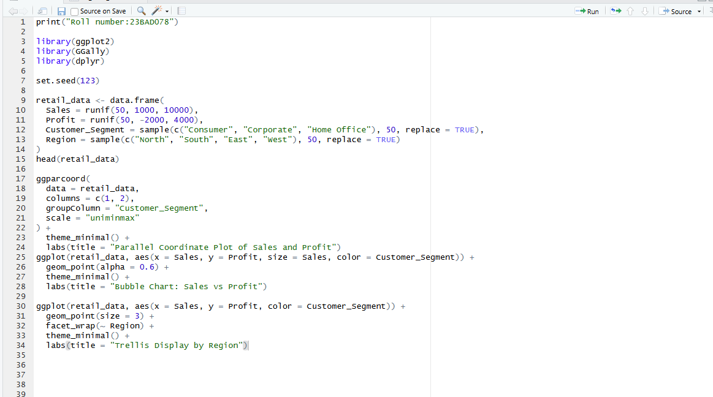
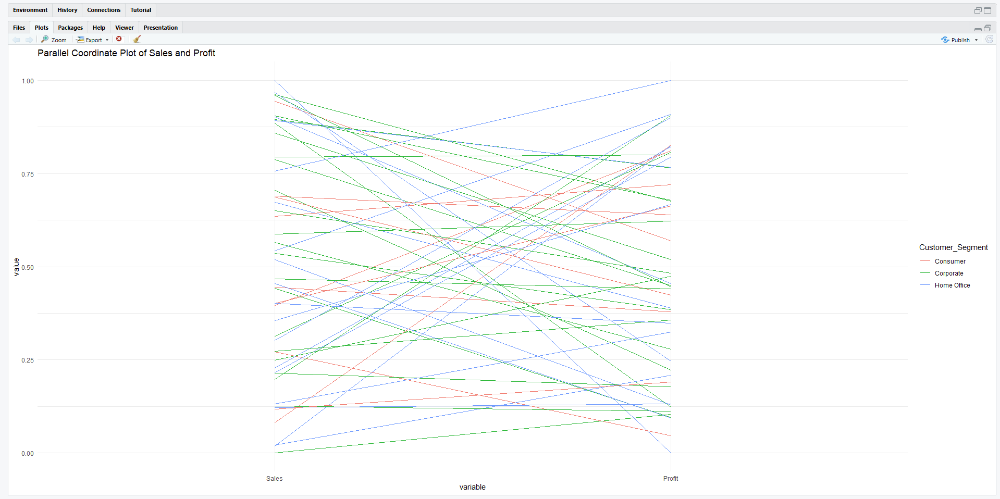
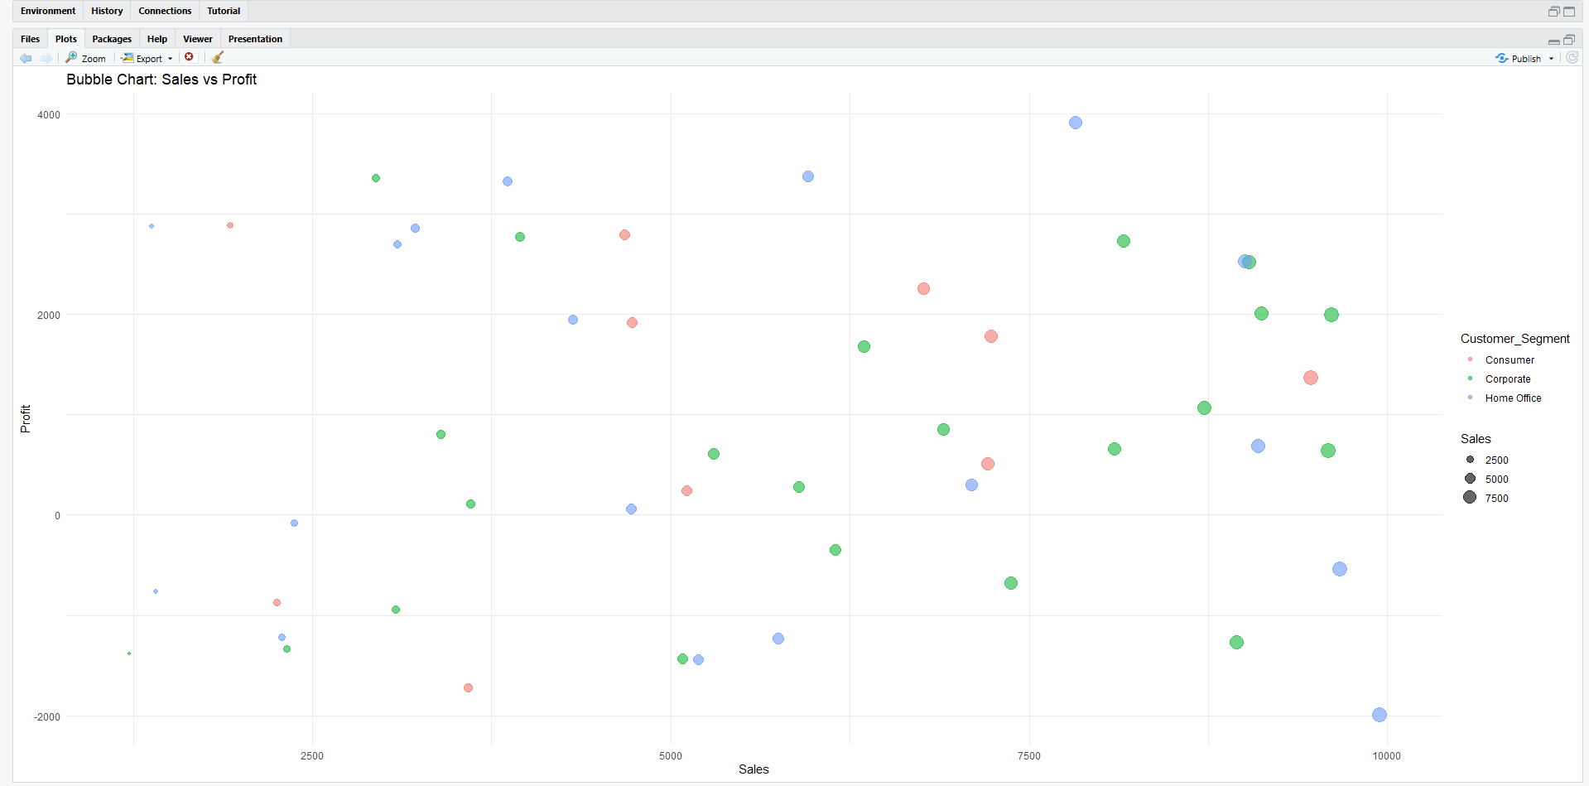
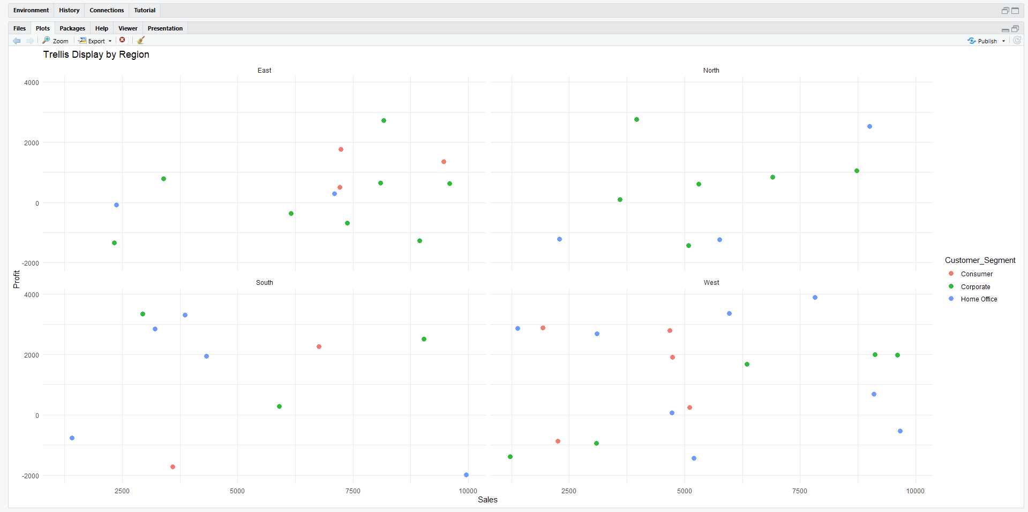

POST-LAB QUESTIONS
- What insights are gained from parallel coordinates?

Answer: They reveal relationships, trends, and outliers across multiple variables simultaneously.

- How does faceting simplify complex data?

Answer: It breaks data into smaller panels, making comparisons across categories easier.

- What limitations exist in bubble charts?

Answer: Overlapping bubbles and difficulty in judging size accurately can reduce clarity.

- How can these displays support AI-driven recommendations?

Answer: They help identify patterns and feature interactions that guide better model decisions.

- Suggest improvements for large multivariate datasets.

Answer: Use filtering, dimensionality reduction, interactivity, and aggregation to reduce clutter.

LEARNING OUTCOME: Students apply multivariate visualization for business intelligence.

ASSESSMENT
Description | Max Marks | Marks Awarded
Pre Lab Exercise | 5
In Lab Exercise | 10
Post Lab Exercise | 5
Viva | 10
Total | 30
Faculty Signature

